find the moment

– integrating ads into opentasks. Sponsor: Cheetah Mobile

– Srping 2016 14-844: Special Topics: Mobile Advertising

This is a design document on the idea of integrating ads with rewards into OpenTasks, an Android mobile app that lets user manage tasks.

Document outline:

* Introduction
* OpenTasks
  + User behavior: how does users interact with OpenTasks
  + Motivation: why and when does users use OpenTasks
* kiip SDK
* Preliminary placement design

Tools:

 OpenTasks: <https://play.google.com/store/apps/details?id=org.dmfs.tasks>

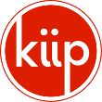 kiip SDK: <http://docs.kiip.me/en/sdk/>

References:

* Mobile Ad lecture slides
* <http://www.kiip.me/brands/>
* <https://support.google.com/adwords/answer/2615875?hl=en>
* <https://www.quora.com/What-is-the-average-CTR-on-Facebook-ads>

# introduction

There are many forms of adverting in the mobile world. Common ones we see include banner ads, pop up ads, video ads and native ads.

The effectiveness of mobile ads depend on many factors. For instance, the content of the ad could affect whether it will catch users’ attention. The relevance of the ad also plays a big role. Facebook ads is a good example of selecting/displaying ads that utilize user’s information. Moreover, ads placement is also an essential component of ads design.

In this document, we discuss placement design based on a given mobile app (OpenTasks) and mobile ad SDK (kiip SDK).

# opentasks

OpenTasks is a mobile application that helps users manage tasks more easily. Its main functionalities including but not limited to creating task with priorities, setting reminders, and tracking tasks’ progress.

## User behavior: how does users interact with OpenTasks

OpenTasks provides a simple user interface that allows user to create and manage tasks

In this section, 3 basic functions are explained with example:

* Create task
* Edit task
* Complete task

### Create task

User can create tasks and put them under different categories.

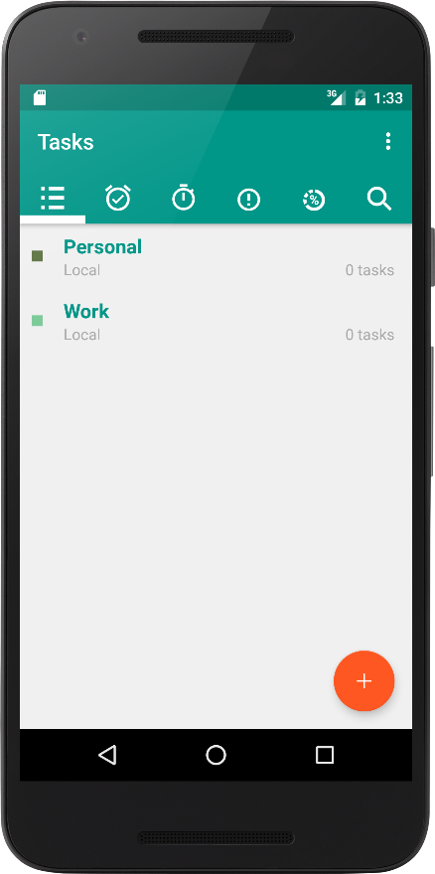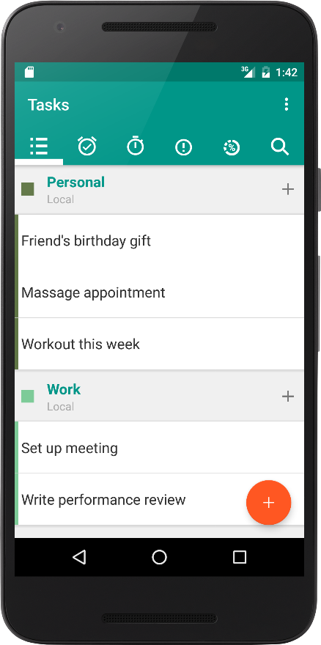

Tasks can be created under each category

User can create categories of tasks such as Personal, Family, and Work etc.

### edit task

Once a task is created, it can be edited.

Below is a workout task created for demonstration. In this workout task example, there are 3 items (check lists) added, corresponding to 3 days of workout in the week by Friday April 8th. In order to finish the task, all 3 items need to be finished.

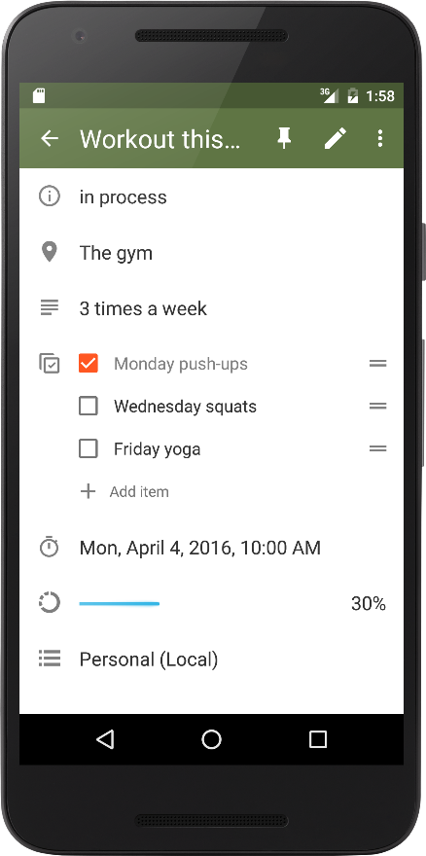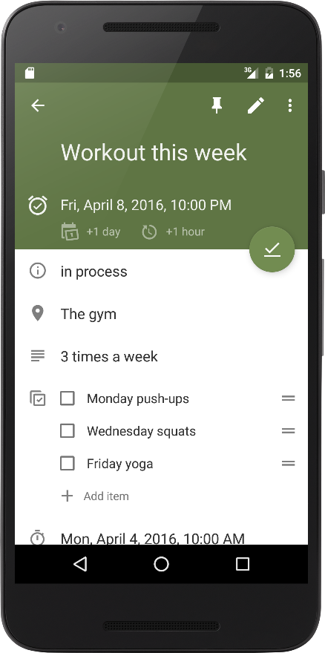

User can mark 1 item as done and also to track the progress.

3 items are added for this task.

A due date for this task

### complete task

A task is completed when user marks it done or all check lists have been checked.

In this example, user has done all 3 workouts in a week and checked all 3 check list.

Once a task is finished, it will disappear on the tasks list. Mission accomplished!

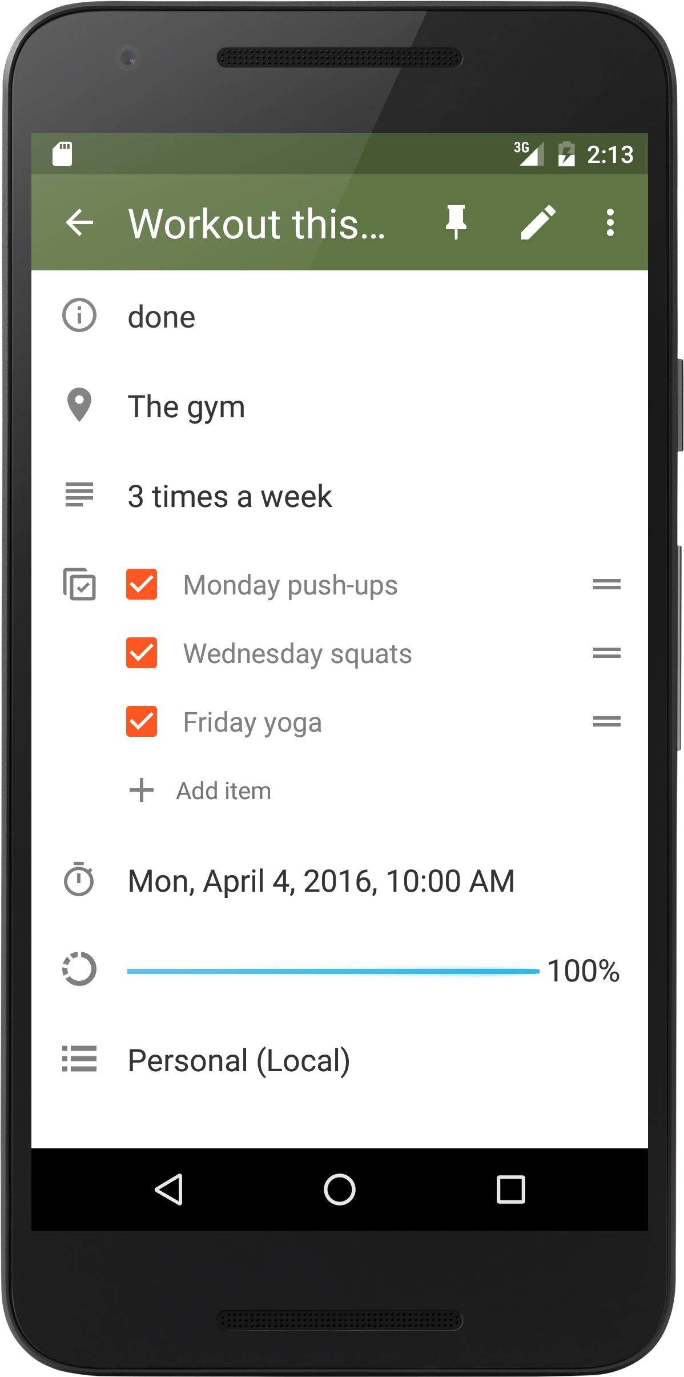

Progress bar shows 100%.

pr

All check lists are checked.

pr

Status changed from ‘in progresses to ‘done’. Meaning the task is completed.

## motivation: why and when does users use OpenTasks

In my opinion, the motivation of OpenTasks is very simple yet important: to keep users motivated and organized in the things they want to and need to do. It provides ease-of-use user interface that allows users to easy manage task and track progresses.

As mentioned in the previous section, there are different categories user can create to management different types of task. This brings a lot potential to what OpenTasks can be used for. It could simple be a task item as shown in the workout task example; or it could be a memo. For instance, a shopping-list that user can track the items purchased.

Therefore, such a mobile app can indeed be used almost any time in anywhere (as long as user has his/her mobile devices).

# kiip SDK

“Connecting brands with people in rewarding ways.”

* http://www.kiip.me/

Kiip SDK allows developers to add advertisements into mobile apps in a rewarding way. In other words, it shows an ad when the moment came. The ads are usually coupons from different brands.

## Ad format

Kiip SDK add ads in a pop-up format that shows in the middle of the screen.

Below is an example of how an ad appears (image: [www.cmo.com](http://www.cmo.com/articles/2014/10/17/kiip_cmo_com_intervi.html)):

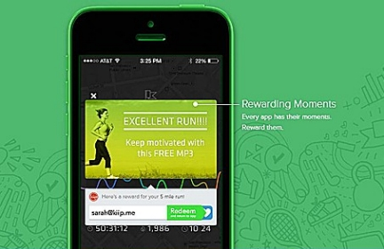

## ad moment

Developers can define the moment when an ad should appear. A good example of a moment is that when user accomplishes something. This is a good timing for the user to be rewarded, for instance a coupon. In this way, the ad is less intrusive, and perhaps even motivates user.

## ad content

Content can be restricted to appear more relevant. This can be set (by the developer or program). Various tags can be added to target more relevant brands. This is another way to make ads less intrusive to users.

# Preliminary placement design

Here I propose a few placement design that brings ads into OpenTasks. Designs are tightly related to the functionality of the app and the nature of kiip SDK, which are discussed in detail in the previous sections.

Below are two example of ads in kiip. They both share similar format and offer user a reward.

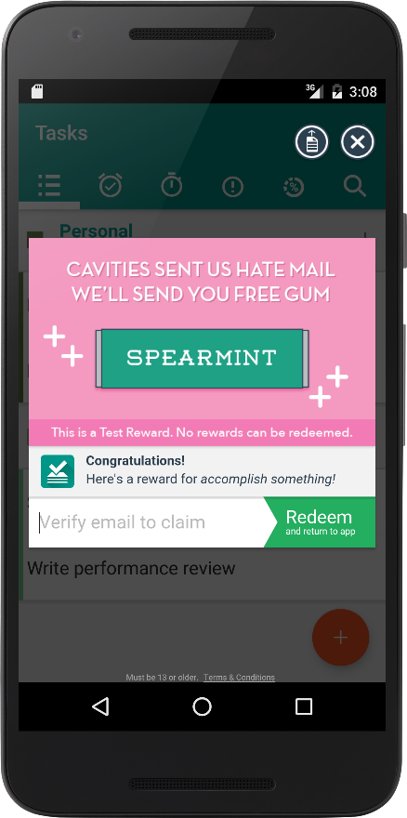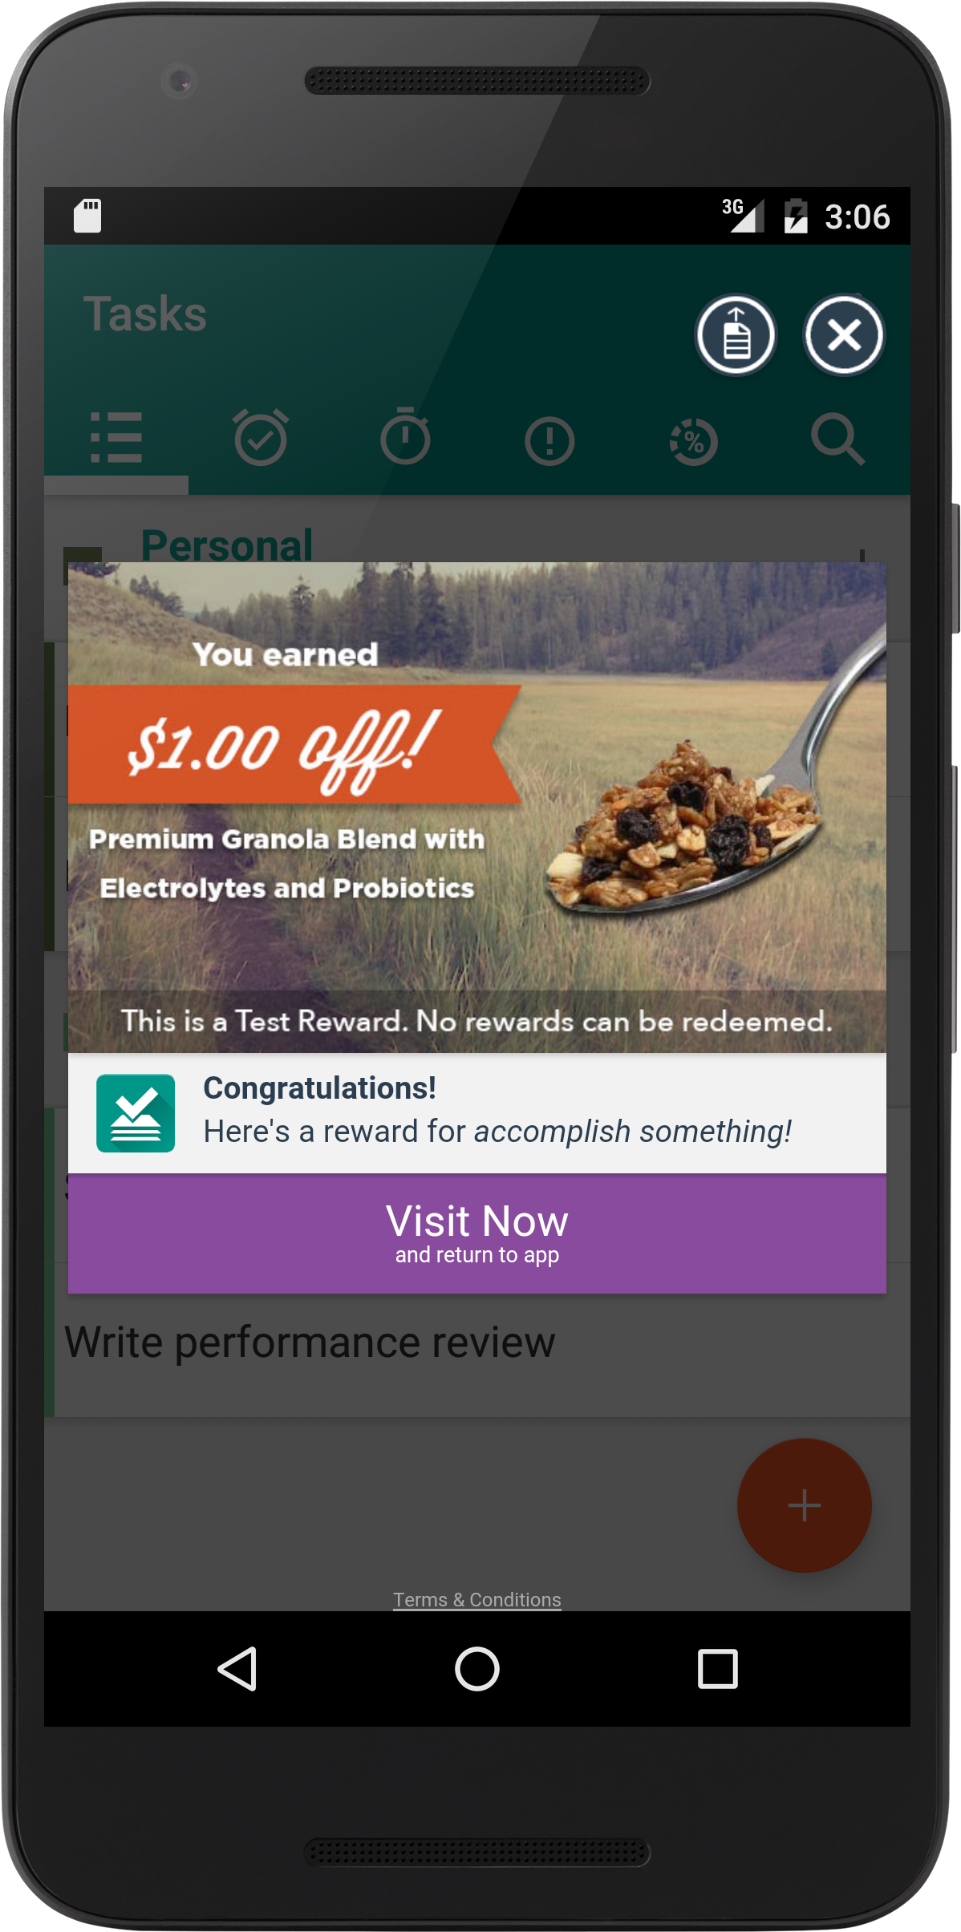

User enters email address to redeem coupon.

User can visit the brand’s website.

## the moment

Since OpenTask is a productivity app, it has a sense of reward built-in. There are various moments we can discover for the users to be rewarded, hence to display the ads.

There are a few things we’d want to pay attention to in terms of finding the moment to integrate ads:

* Moment shall not be easily triggered. We need to keep ads displaying at the reasonable rate.
* Ads shall not be intrusive or affect user using the app. Ads should be display when it’s at a “break point” of using the app. For example, showing an ad when user is in the middle off editing a task is intrusive.
* Besides satisfying the first two criteria, moment shall be picked when a reward is involved. For instance, displaying an ad after a user deletes a task (instead of completing a task) is not a good representation of a rewarding moment. In other words, a user should only be seeing an ad, which is a coupon, when he/she feels that he/she has accomplished something. It should be a rewarding moment instead of just any moment.

Here are some examples of the moments:

* When a user finishes an item within a task (needs to make sure it doesn’t appear too frequently)
* When user completes a task
* Based on users’ behavior and information, it can be at a certain time in a week. To make smarter decisions, some machine learning algorithm can be used.

Here are some of the example:

* + If we know when user gets up or goes to sleep, we could find a moment to add an ad. For instance, would an ad pops up before user goes to sleep be appropriate? Of course this should not be an everyday routine.
  + Suppose we know a user has a Monday to Friday work schedule, and gets off work around 6 PM. After 6 PM, if the user opens the app and starts making plans for the weekend, we can add an ad saying "This is a reward for a week of hard work!"
  + We may utilize user's information such as birthday and ceremony and integrate ads at these occasions.

## click-through rate (CTR) estimation

Without any prior experience in advertising, I am purely making this estimation from personal experience.

After sometime after playing with OpenTasks and kiip SDK, I do find this form of advertisement quite compelling for the following reasons:

* OpenTasks provides a clean user interface that lets user manage daily tasks and keep thing organized. When a task is completed, it feels good to get it off the list. This is a moment when the user is feeling accomplished.
* As we know, one way to keep people motivated is to offer rewards. This is when kiip SDK comes into play. When an ad appears at this moment, since my mood was just boosted up a little by completing a task, I’m less likely to feel annoyed by the ad. Moreover, the ad is not interrupting an action in the app.
* To me, the content appears to be relevant and nature. It could be due to these reasons:
  + Kiip presents the ads in a way that blend well with the mobile app (it looks good and easy on the eyes).
  + The contents are relevant because I, as the developer, selected the tags so relevant ads will appear.

Base on reasons above, I estimated there are 5 click per 1000 impression, which results in a 0.5% CTR, which is quite optimal.